Courtney Thurston

AP Computer Science B

Mrs. Calinisan

April 19, 2014

GridWorld Case Study Part 1

Do You Know Question Set 1:

1. No; the bug will move forward when there is an empty space, or when the space is currently occupied by a flower.
2. Forward.
3. Turns right 45 degrees.
4. It leaves behind a flower.
5. The bug will either continue turning rightward by 45 degrees or it will move off of the grid, leaving behind a flower.
6. It turns right 45 degrees.
7. No.
8. The flowers die overtime, visibly becoming darker.
9. No.
10. No, only one.

Part 1 Exercise Question Set:

1. 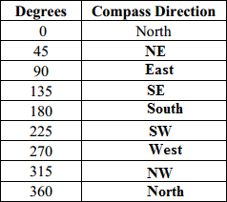
2. If the space is empty or currently occupied by a flower, the bug should be able to move there using the moveTo method. The bug will continue forward unless its direction is changed with the setDirection or turn method(s). Moving the bug outside the grid will result in an IllegalArgumentException exception.
3. The setColor method is used for this purpose.
4. The bug is no longer visible, even when the rock is later moved. When one grid object is moved on top of another, the first one to have occupied that space will disappear.